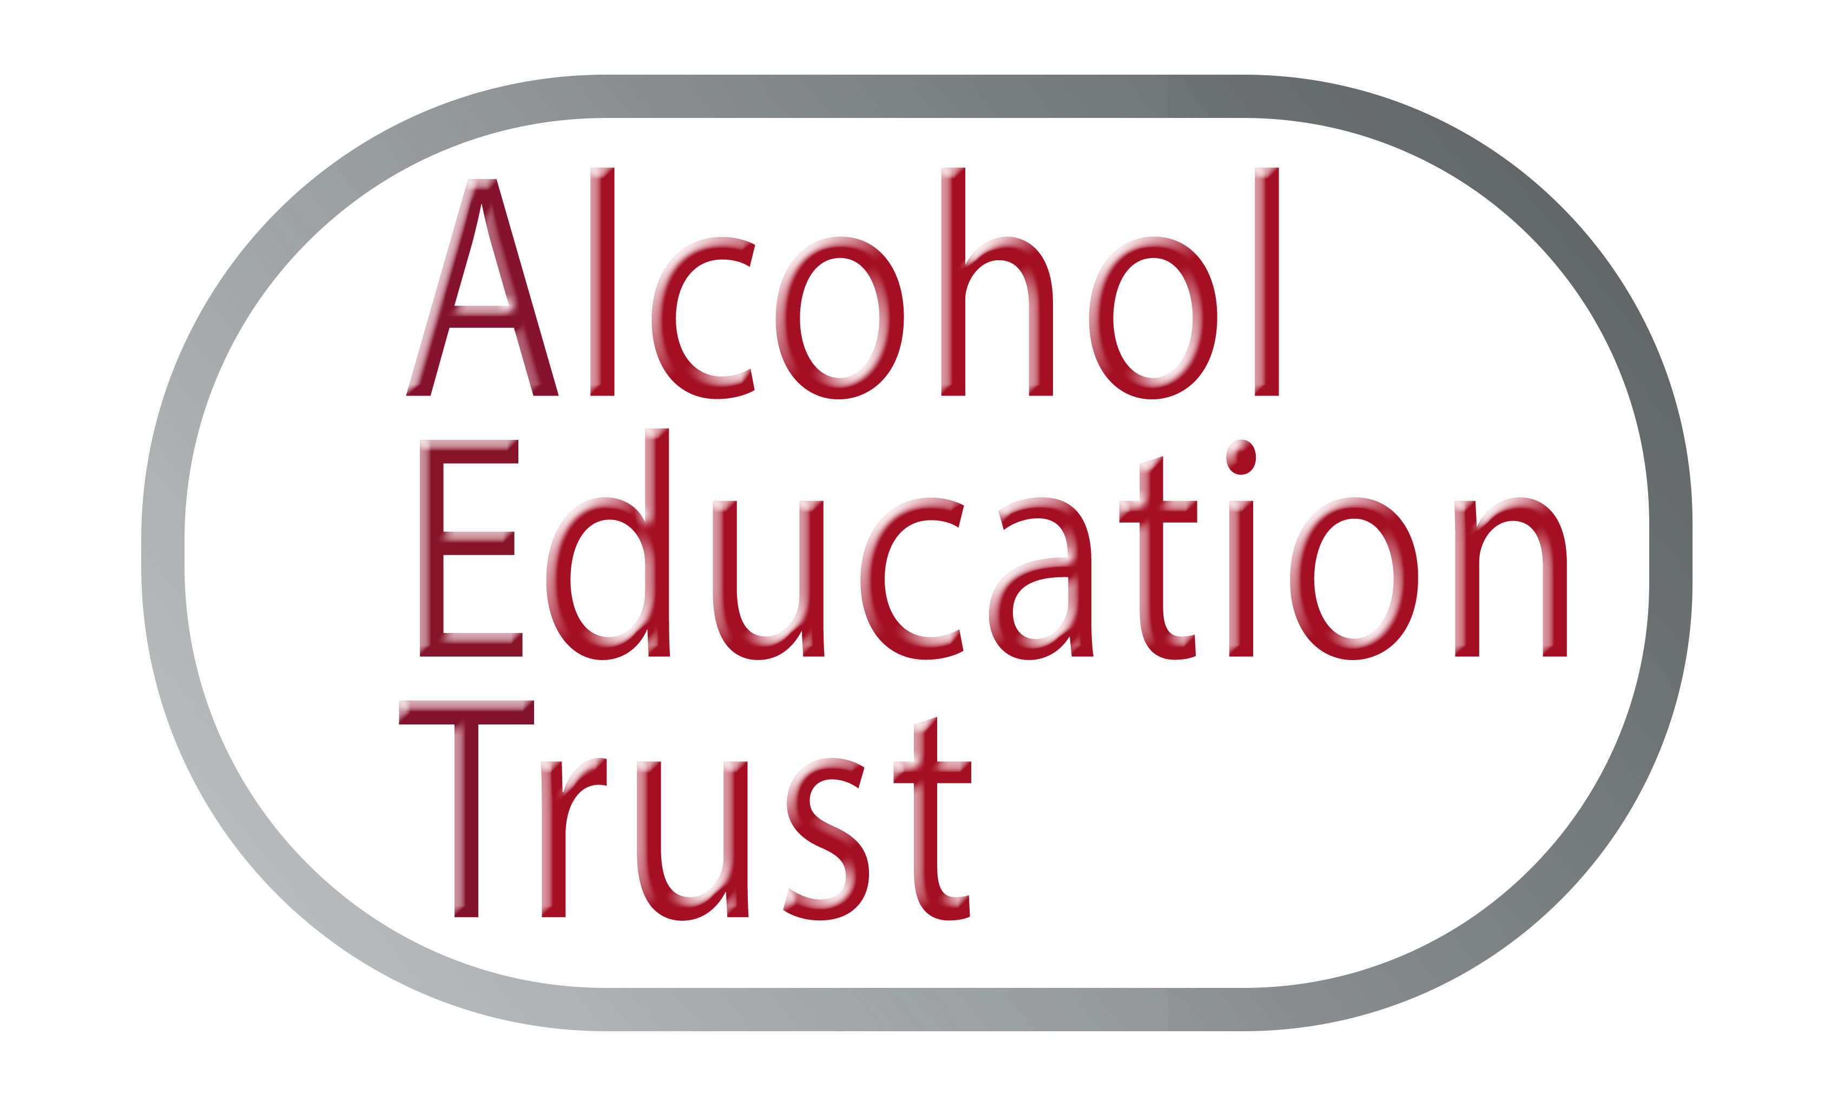
Alcohol Education Trust - Resources order form
Please complete the following and email to kate@alcoholeducation trust.org

Contact Name
Contact email
School/ Organisation
Job Title
Delivery Address

Resource | Unit price | Quantity | Cost

Training sessions and workshops

100 page Talk About Alcohol workbook of 30 lesson plans, guidance, activities and games suitable for 11-18 year olds | £45 per copy  (£25 per copy for orders of 4 or more)
Full Talk About Alcohol education pack including classroom activity cards, DVD, additional SEN lessons, guidance and powerpoints | £90.00
Alcohol and you leaflet  Minimum order of 50 copies | £0.20
Talking to kids about alcohol guide  Minimum order of 50 copies | £0.25
Just a few drinks’ BAFTA award winning 4 short films DVD | £10

